Year Group: | 3 | Subject: | Art & Design
Term: | Autumn | Topic: | Animals in art

Links to Previous Learning |  | What you should know:
Techniques of painting - watercolours, thick paint, colour-mixing, dotted painting |  | Stone Age men decorated their caves with images of the  animals they hunted for food.
Techniques of collage |  | Megan Coyle is a collage artist who creates artwork from magazine strips.
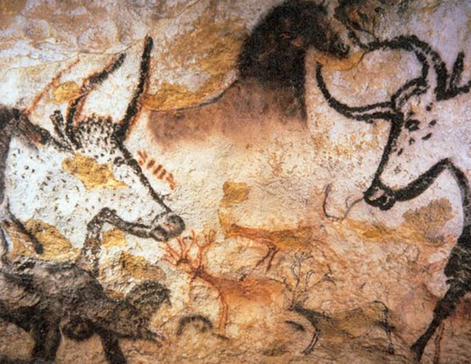
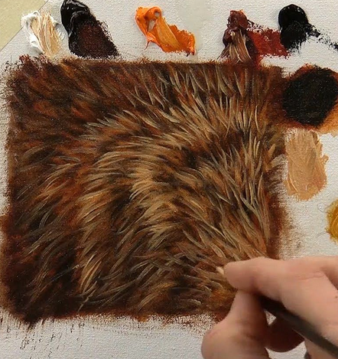
Megan Coyle “paints with paper”. What does that mean?
Key Fact: Animals have been a source of inspiration for artists for thousands of years.

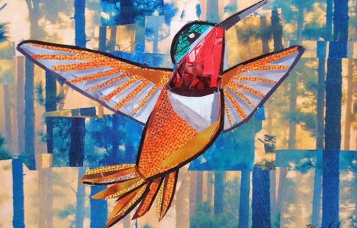

Key Vocabulary
form | shape
motion | the way something moves
masterpiece | the best piece of work someone has produced
At home:
Find out more about Megan Coyle https://megancoyle.com/

Find out about other artists who were inspired by animals, e.g.

- Rosa Bonheur (1822-99) French painter and sculptor
- Franz Marc (1880-1916) German painter and printmaker
- Damien Hirst (born 1965) British artist

