Year Group: | Reception | Areas of Learning: | Personal Social and Emotional Development, Communication and Language, Physical Development, Expressive Arts and Design, Understanding the World.
Term: | Spring | Topic: | People Who Help Us

What I already know… |  | 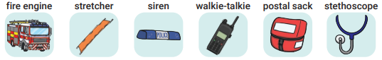  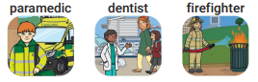  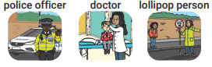  Who can help you at home? Who can help you at school?  Who might use any of the apparatus? | What I know now…
I can talk about people at home and at school who can help me.
I can name different types of people who help others.
I can talk about people in my community that help to keep others safe and healthy.
I can describe how people in my community help others and things they do in their jobs.

New vocabulary |  |  | What I can do at home
Occupation | The work a person does to earn a living; a job. |  | Talk about road safety and practise crossing the roads safely together.  Talk about ways humans keep themselves healthy, for example, brushing our teeth or eating healthy foods.  Talk about people who have helped us in our lives and think of a way to say ‘thank you’ to them.
Rescue | To free or save someone or something.
Apparatus | Tools or equipment needed for a special task.

