Year Group: | 3 | Subject: | Art
Term: | Autumn | Topic 02: | Renaissance

Links to Previous Learning |  | What you should know:
Techniques of drawing - still life, observational drawings |  | The Renaissance was a period in European history.
Countries of Europe |  | It began in the 1300s, during the late Middle Ages. It ended during the 1500s, when the modern era began.
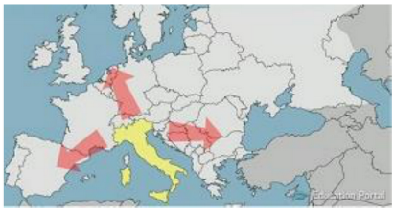
Key Fact: The Renaissance (French for “rebirth”) was a great revival of art, literature, and learning in Europe.
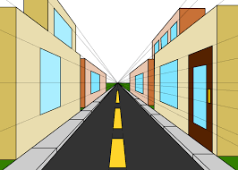

Why was Leonardo Da Vinci a significant artist?

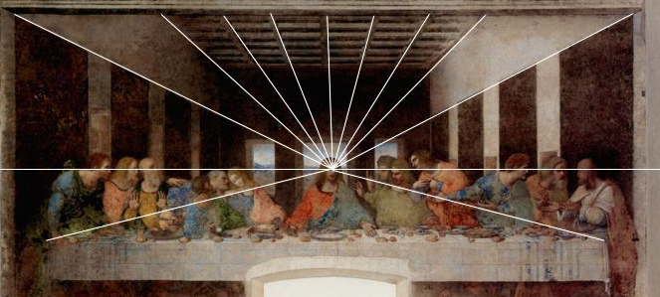

Key Vocabulary
renaissance | rebirth, renewed popularity or success
knowledgeable | having knowledge or intelligence
realism | presented in a way that is like real life
depth | appearing 3D rather than flat
permanent | lasting forever, not expected to change
perspective | the right impression of the size and position

At home:
Try to do a drawing using perspective. https://www.youtube.com/watch?v=If2O3dGPcpo

Find out about other artists from the Renaissance period, e.g.
Donatello (1386-1466) Italian sculptor
Leonardo da Vinci (1452-1519) Italian painter and sculptor
Michelangelo (1475-1564) Italian painter and sculptor
Raphael (1483-1520) Italian painter

