Year Group: | 4 | Subject: | Computing
Term: | Autumn 2nd Half | Topic: | Creating Media- Audio Editing

Links to Previous Learning |  | What you should know:
 |  | Use search technologies effectively
 |  | To question content online
create a debug simple programs |  | Select, use, and combine a variety of software (including internet services)
 |  | Use technology safely, respectfully, and responsibly
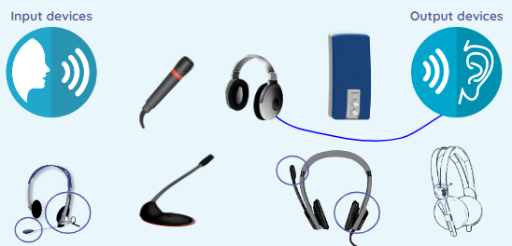
Agree or Disagree? All podcasts are useful.
Key Fact: with the right equipment and skills, anyone can create a podcast so always question what you are listening to.

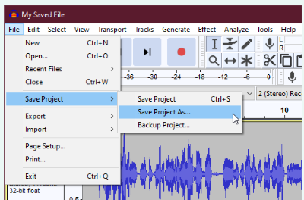

At home: listen to and review some age appropriate podcasts e.g.
Key Vocabulary
input | a place where, or a device through which, energy or information enters a system
output | a place where power or information leaves a system.
podcast | a digital (computer) file you listen to
audio recording | a recording (file) of only speaking (no picture)

