Year Group: | 3 | Subject: | History
Term: | Autumn, Spring & Summer | Topic 01: | Stone Age

Links to Previous Learning |  | What you should know:
Some events happened only a few years ago, or in my family’s memory. |  | The oldest period of the Stone Age, the Palaeolithic period, began approximately 2.5 million years ago. People were hunter-gatherers.
Some events happened a very, very long time ago. |  | The Middle Stone Age is called the Mesolithic period. People were hunter-gatherers.
Some events changed the way that we live now. |  | The Neolithic period, often called the New Stone Age, dates back approximately 8–10,000 years. People became farmers.
We can find out about the past through different methods, e.g. reading, artefacts etc |  | The Stone Age ended when people began to use metal for tools.
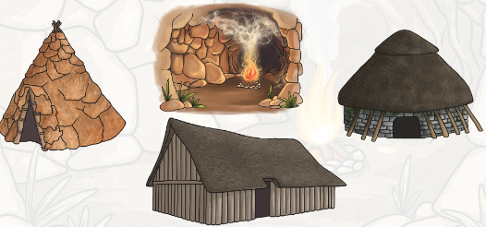
Key Fact: Prehistoric refers to a time before writing had been invented. We have to find clues to tell us about life in the past.
True or False? people in the Stone Age were only interested in finding food and shelter.
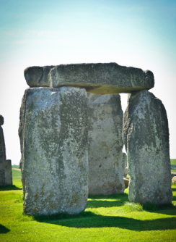

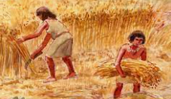
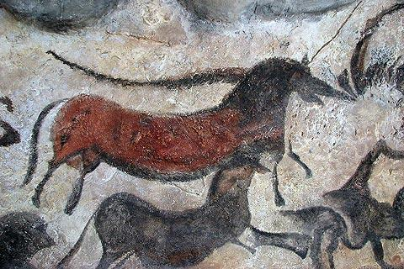
At home:
Investigate Stone Age cave paintings. Try making your own pigments from natural materials.

Find out more about Prehistoric Britain: https://www.bbc.co.uk/bitesize/topics/z82hsbk

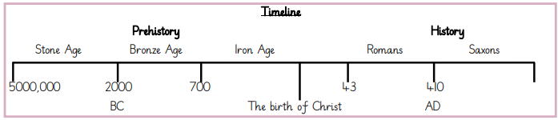
Key Vocabulary
ancestors | relatives from long ago, people who someone is  descended from, older than a grandparent
nomadic | travelling from place to place
communal | shared by a group of people
historical sources | things that give information about the past
archaeologists | people who study the past by examining remains and objects

