Year Group: | Year 2 | Subject: | Geography
Term: | Autumn Term | Topic: | Describing maps of the world

Links to Previous Learning |  | What you should know:
What is a globe? |  | Use compass directions (North, South, East and West).
What is a map? |  | Use the words near and far to describe locations.
What is an atlas? |  | Describe routes on a map.
Label a compass rose showing NSEW. |  | Where the North and South hemispheres.
Key Fact: I know maps show us where places are.
How are maps and globes different?
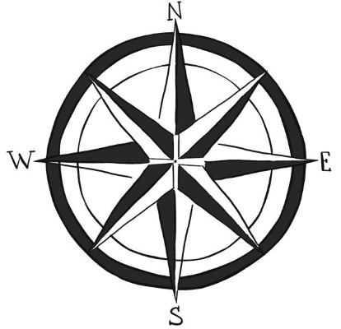
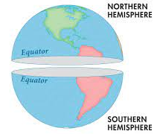

Key Vocabulary
compass rose | a compass gives direction.
techniques | a technique is a method of doing something
Northern and Southern hemisphere | the two halves of the world above and below the equator
location | a place or position

At home: Use a compass and a map to plan a route and go for a walk.

