Year Group: | 3 | Subject: | Art
Term: | Summer | Topic 05: | Abstract Art

Links to Previous Learning |  | What you should know:
Techniques of painting - watercolours, thick paint, colour-mixing, dotted painting. |  | Abstract art is a modern form of art where the picture or sculpture produced does not represent images of our everyday world.
Techniques of drawing - still life, observational drawings. |  | ‘Colour field painting’ became popular as a form of abstract art in the 1950s. Artists who used this style tried to paint emotion onto large canvases using solid, geometrical shapes of bright colour.
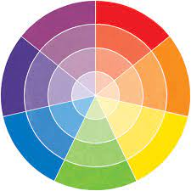
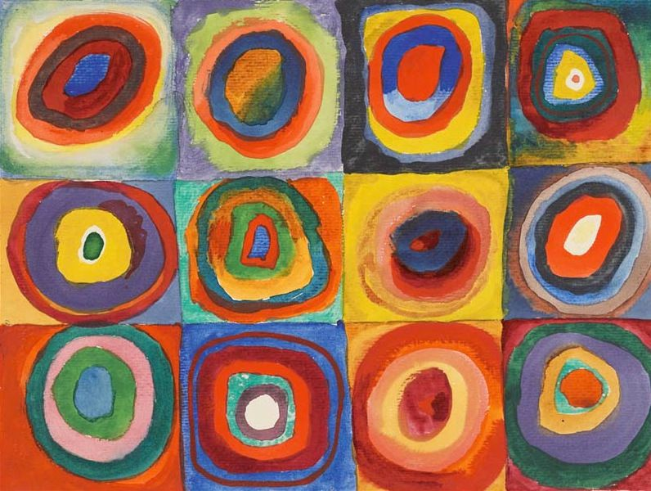
Key Fact: Abstract artists have planned their work in great detail, with the intention of capturing emotions and thoughts.
Key Vocabulary
random | not following a plan or pattern shapes and lines
outline | the edge of an object or shape shown with a line
transparent | can be seen through
chromatic | having colours
Why do abstract artists often use strong contrasting colours?
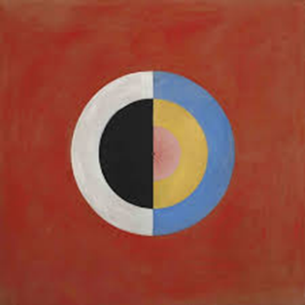
At home:
Try to do a drawing or painting inspired by Wassily Kandinsky. https://www.youtube.com/watch?v=vDWmLlNicMU

Find out about other abstract artists, e.g.
Piet Mondrian (1872–1944) Dutch painter
Henry Moore (1898–1986) English artist and sculptor
Sonia Delaunay (1885–1979) French painter
Jackson Pollock (1912–46) American painter

