Year Group: | Reception | Areas of Learning: | Personal, Social and Emotional Development, Physical Development, Communication and Language, Expressive Art and Design, Understanding the World
Term: | Autumn 1 | Topic: | All About Me

What I already know… |  | 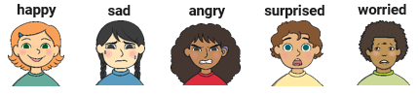  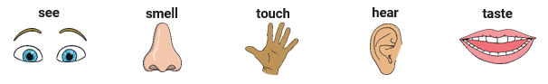  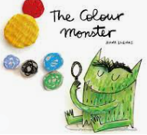  ‘The Colour Monster’ pairs colours with feelings. Can you match the colours to the feeling? Green  Yellow Pink Grey  Red Black Blue | What I know now…
I can name my emotions.
I can talk about people in my family.
I can talk about things that are the same and different between myself and others.
I can talk about where I live.
I can compare where I live to other places and say what is the same and what is different.
I can name my five senses.
I can name the parts of my body.

New vocabulary |  |  | What I can do at home
emotions | a feeling such as happy, sad, worried or angry |  | Look at some family photographs together and talk about who you can see.  Sing ‘head, shoulders, knees and toes’. Change the words in the song to different body parts.  Walk around the local area and talk about the different homes you spot along the way.  Openly talk about feelings and talk about why you are feeling that way.
senses | any of five ways to understand or experience the world around me
unique | being the only one of its type

