Year Group: | Year 2 | Subject: | Geography
Term: | Autumn Term | Topic: | Extreme Weather

Links to Previous Learning |  | What you should know:
Label common weather extreme weather symbols |  | How to compare and contrast three different types of extreme weather.
What a heatwave, what is a drought, what is a flood, what is a monsoon? |  | To summarise the effect of floods from monsoons in Bangladesh.
 |  | The location of hot and cold areas of the world in relation to equator and the North and South Poles.
Key Fact: extreme weather and climate change impact on our world.
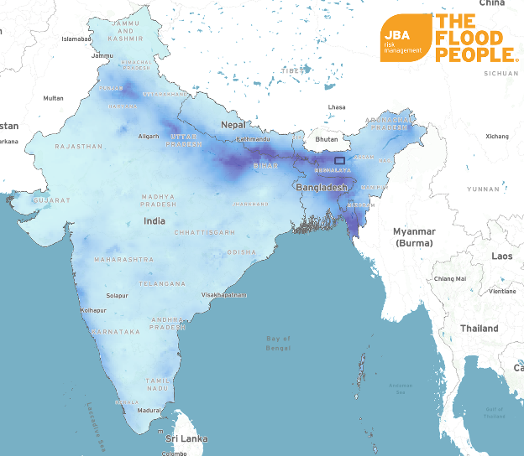
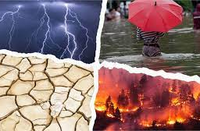
How is extreme weather linked to our changing climate?

Key Vocabulary
heatwave | a long period of the weather
monsoon | seasonal heavy rain in the continent of Asia
cyclone | very strong winds in a circular pattern
tornado | a large column of rotating air

At home: research any current extreme weather events in the world.

