Year Group: | Year 2 | Subject: | Design and Technology
Term: | Autumn Term | Topic: | Solid Structures

Links to Previous Learning |  | What you should know:
Identify different types of structures. |  | To explore design features of solid structures.
Make an anchored frame. |  | To explore the stability and strength of towers and walls.
Plan, design and make a chair. |  | To plan, design, and evaluate the construction of a bridge.
Key Fact: Structures need to be balanced and have solid foundations.
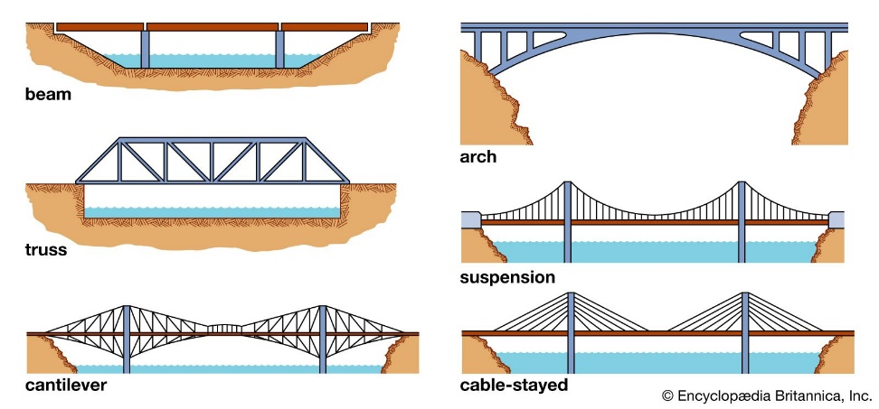
How can you make your structure solid?
Key Vocabulary
solid | made of objects that have little or no space inside them
balanced | if an object is balanced, it stays steady and does not fall
bond | how bricks are arranged
foundations | the underground bases of structures

At home: Practise building different structures using blocks and bricks. What is the tallest tower you can make?

