Year Group: | Year 2 | Subject: | Art and Design
Term: | Autumn Term | Topic: | In the Dark of the Night

Links to Previous Learning |  | What you should know:
How do artists use contrast between light and dark? |  | To explore different methods and materials.
Know that Van Gogh painted Starry, Starry Night. |  | To use some of the ideas of artists studied to create pieces.
Copy wash techniques when painting the sky. |  | To explore expressive styles of art.
Key Fact: Artists use different colours and techniques to express different moods.
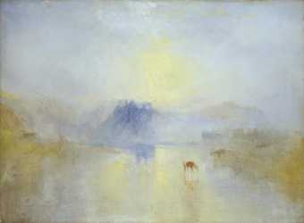
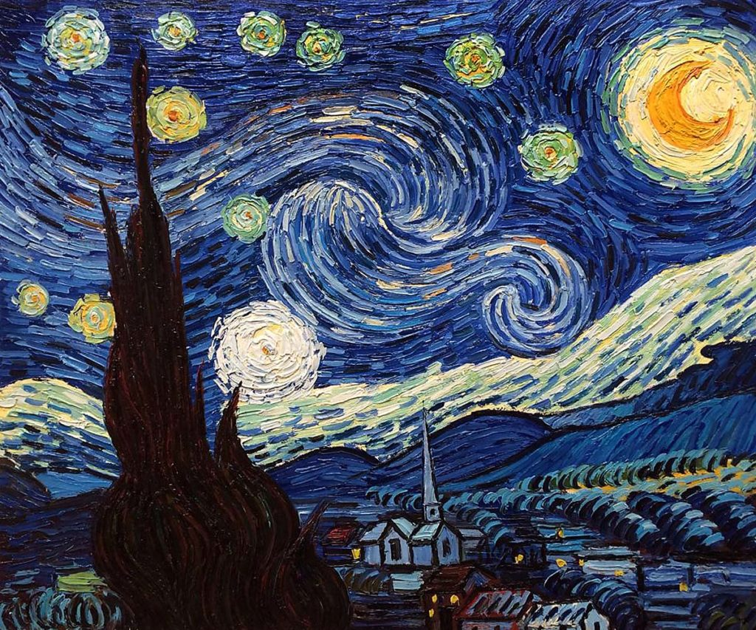
How do different colours make you feel?

Key Vocabulary
depth | appears more real, in 3D rather than flat
expressive | full of meaning or feeling
symbolise | using shapes, colours and designs to represent an idea

At home: Visit a DIY store and collect some colour samples, can you mix paints to make the colours?

