Year Group: | Reception | Subject: | Personal Social and Emotional Development, Communication and Language, Physical Development, Expressive Arts and Design, Understanding the World.
Term: | Spring | Topic: | Traditional Tales

What I already know… |  | 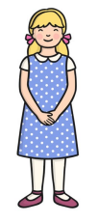  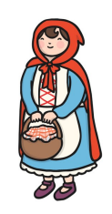  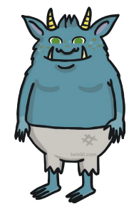  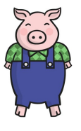  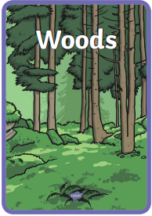  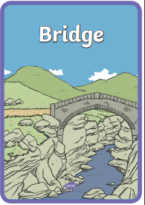  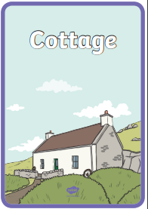  Can you remember the titles of the Traditional Tales that these characters are from?  What Traditional Tales can you think of that have the woods, a cottage or a bridge as a setting in the story? | What I know now…
I know what a story is.  I have listened to a range of different stories. |  |  | I know what a setting is in a story.  I know what a character is in a story.  I can describe a setting  I know what a repeated refrain is.  I know stories were written in the past.  I can make comparisons and links between stories I have read.  I can interpret stories through singing, dancing and drama.
New vocabulary |  |  | What I can do at home
Tales | Another word used for ‘story’. |  | Read new stories and make comparisons between them and a tradition tale that you have experienced.  Talk about how characters might be feeling during the story and make links to times you may have felt that way too.  Make stick puppets of characters and act out the stories together.
Setting | The environment in which an event takes place.
Character | A person in a story, play, or movie.

