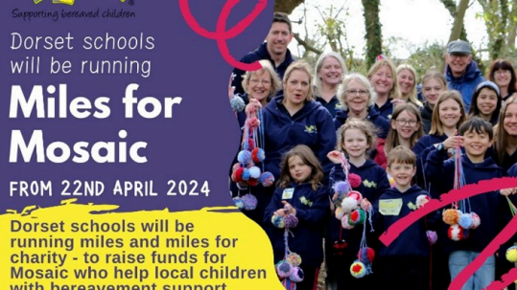

Julie Thorp

Frome Valley First School - Miles for Mosaic 2024

Fundraising for MOSAIC - Supporting Bereaved Children

£407

203 %

raised of £200 target

by 31 supporters