Year Group: | 4 | Subject: | History
Term: | Autumn | Topic: | Anglo Saxons 1

Links to Previous Learning |  | What you should know:
Label a timeline with key dates in the history of the Roman Empire. |  | Label a timeline with events of the Anglo Saxon era.
Know the key dates of Roman Britain.  Name the emperors who came to Britain.  When was Britain conquered by the Romans?  When was Julius Caesar assassinated?  What was the name of the first emperor of Rome? |  | Name and show on a map the names of the Anglo-Saxon kingdoms.
 |  | Name the reasons why Anglo Saxons came to England.
Explain the impact and influence of the Romans on Britain. |  | Use evidence to ask questions and find answers to questions about the past.
Key Fact: Anglo Saxon England lasted from 5th to the 11th centuries, from the end of Roman Britain until the Norman conquest in 1066.
Why did the Anglo Saxons come to England and how long for?
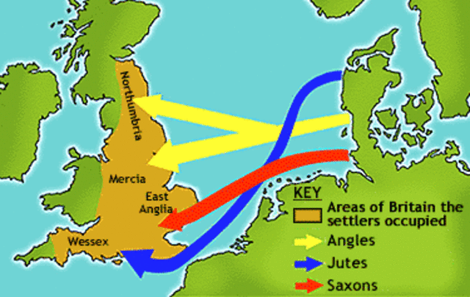
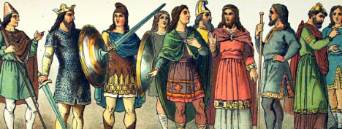

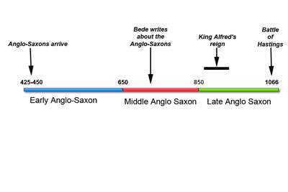
At home: draw or find a good online timeline of Anglo Saxon times. Then, explain the timeline to an adult.
Key Vocabulary
conquer | took control of by force
medieval | the period of European history
pagan | relating to beliefs that are not part of our major religions
descendants | relatives from later generations
historical source | piece of writing from the past
primary source | an object from the past

