Year Group: | 3 | Subject: | Art
Term: | Spring | Topic 03: | Myths and legends

Links to Previous Learning |  | What you should know:
Techniques of painting - watercolours, thick paint, colour-mixing, dotted painting. |  | Pre-Raphaelite artists were inspired to create art based on fantasy and stories but tried to make them look real.
Techniques of drawing - still life, observational drawings. |  | Most Pre-Raphaelite painting is incredibly detailed, very bright coloured and uses symbols to help people understand the painting better.
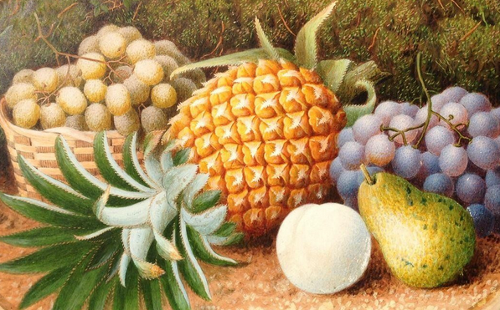  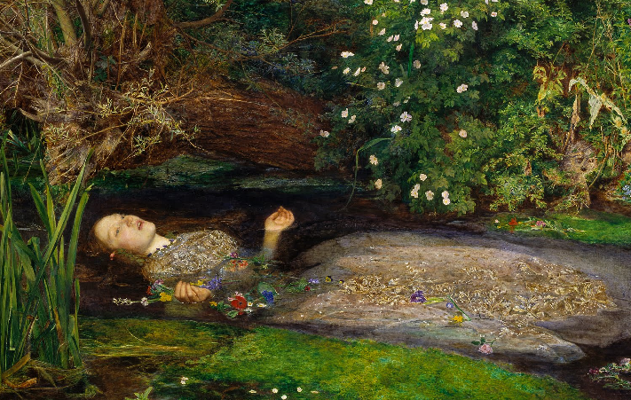 |  | Joan Jonas is an American artist who is fascinated by myths and legends.
 |  | She created The Juniper Tree, inspired by a story by the Brothers Grimm, using a combination of 24 props, paintings, drawings, garments, video and relics.
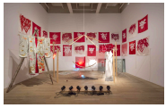

Why is “The Juniper Tree” regarded as an important piece of art?

Key Fact: Myths and legends have been used to inspire works of art for hundreds of years.

Key Vocabulary
myths | well-known stories which were made up in the past to explain natural events or religious beliefs
legends | old, popular stories that may be true
moral | to do with beliefs about what is right or wrong
Pre-Raphaelite | relating to British artists in the 19th century who were influenced by mediaeval history and old stories

At home:
Find out more about Joan Jonas: https://www.tate.org.uk/art/artists/joan-jonas-7726/five-things-know-joan-jonas

Create your own art inspired by a story that you have read.

