Year Group: | 3 | Subject: | History
Term: | Autumn, Spring & Summer | Topic 01: | Bronze Age

Links to Previous Learning |  | What you should know:
Some events happened only a few years ago, or in my family’s memory. Some events happened a very, very long time ago. |  | Bronze was used instead of stone to make tools and weapons.
Some events changed the way that we live now. |  | Woollen cloth was used to make clothes and to keep warm.
We can find out about the past through different methods, eg reading, artefacts etc |  | People were buried with their important possessions.
The Stone Age began approximately 2.5 million years ago. |  | The Bronze Age in Britain spanned from c.2500 BC until c.800 BC, lasting for approx.1,700years.
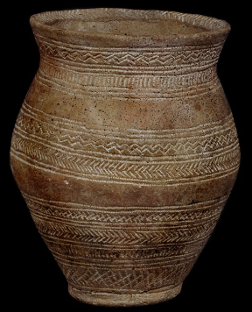
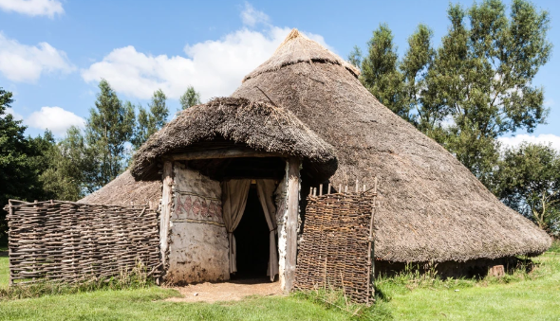
Why did Bronze Age people bury valuable objects with their dead?
Key Fact: Prehistoric refers to a time before writing had been invented. We have to use sources (clues) to tell us about life in the past.

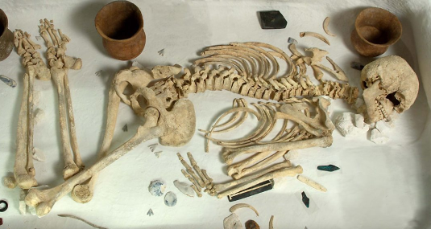
At home:
Investigate Bronze Age hoards from Dorset: https://www.wessexarch.co.uk/our-work/bronze-age-axe-hoard-dorset
What do the artefacts at Amesbury tell us? https://www.wessexarch.co.uk/our-work/amesbury-archer

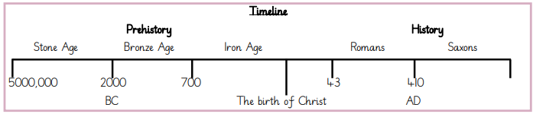
Key Vocabulary
ancient | from a long time ago
hoard | a secret store of valuable items
preserved | kept in its original state
intricate | with many small parts and details
trade | buy, sell or exchange goods

