Year Group: | 4 | Subject: | Science
Term: | Autumn 2nd Half | Topic: | Electricity

Links to Previous Learning |  | What you should know:
Name some appliances that use electricity. |  | Name common appliances that run on electricity.
Know what a light bulb is. |  | Make a simple series electrical circuit and be able to name its basic parts, including cells, wires, bulbs, switches and buzzers.
Know what a battery is (cell) |  | Know whether or not a lamp will light in a simple series circuit, based on whether or not the lamp is part of a complete loop with a battery.
Know what a switch on an electrical device is. |  | Know that a switch opens and closes a circuit and associate this with whether or not a lamp lights in a simple series circuit.
Know it is dangerous to get anything electrical wet. |  | Know some common conductors and insulators, and know metals are good conductors.
Key Fact: voltage measures the power of electricity. The higher the voltage, the more electricity that is flowing.
High voltage is very DANGEROUS
When is a circuit complete/ incomplete?
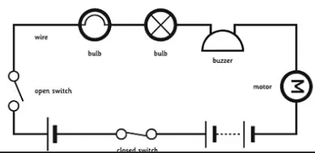

Key Vocabulary
cell | one or more cells make a battery.
circuit | a path which allows electricity to flow
mains electricity | electricity provided form a socket; transported between the building and the power station
insulator | a material that does not let electricity pass through it (easily)
conductor | a material that does let electricity pass through it

At home:
Find and compare the voltage of different electrical appliances in your home.
Can you make an electrical circuit using a fruit or vegetable?

