Year Group: | Reception | Areas of Learning: | Personal Social and Emotional Development, Communication and Language, Physical Development, Expressive Arts and Design, Understanding the World.
Term: | Autumn | Topic: | Fireworks

What I already know… |  | 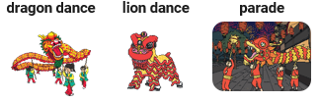  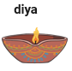  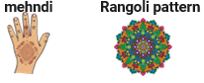  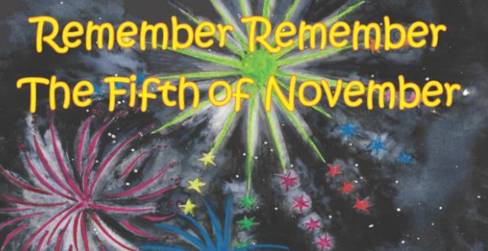  Look at the pictures from festivals that use fireworks to celebrate. What festivals are they?  What do some people celebrate on the 5th November? | What I know now…
I can talk about events that happened in the past.
I can recognise some similarities and differences between life in this country and life in other countries.
I can recognise that people have different beliefs and celebrate special times in different ways.
I can describe what I see, hear and feel.
New vocabulary |  |  | What I can do at home
Celebration | A time of special activities and events. |  | Talk about fire safety rules and why they are so important.  Watch some fireworks together and talk about what you like, dislike, what colours and shapes you saw and the sounds you heard.  Talk about other family celebrations that might involve having fireworks as a special activity.
Tradition | The handing down of a culture's beliefs and customs from parents to children over many years.
Festival | Celebration that repeats, often once a year, and involves special activities.
Diwali | One of the most popular festivals of Hinduism

