Year Group: | Year 2 | Subject: | Art and Design
Term: | Autumn Term | Topic: | Love for Landscapes

Links to Previous Learning |  | What you should know:
Why artists do not see people as an important part of a landscape picture |  | To describe the work of notable landscape artists, artisans and designers.
Who John Ndambo is and some of his artwork. |  | How to mix primary and secondary colours.
Creating a piece of landscape art. |  | To know how to use colour to show different emotions.
Key Fact: Artists use different colours and tones to express different moods.
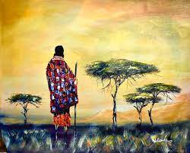
How do different colours make you feel?

Key Vocabulary
imaginary | not real life, made up in the mind
ominous | worrying as if something bad is going to happen
definition | clear detail
speciality | a special interest or skill done well

At home: Go for a walk and look for a landscape to sketch. What colours would you use to paint it?

