Year Group: | 3 | Subject: | Art & Design
Term: | Spring | Topic 04: | All Work, No Play

Links to Previous Learning |  | What you should know:
Techniques of painting - watercolours, thick paint, colour-mixing, dotted painting. |  | Art that shows people at work can be important as it tells us about social history and, in particular, the everyday lives of ordinary people.
Techniques of drawing - still life, observational drawings. |  | Artists think carefully about body language to show emotion.
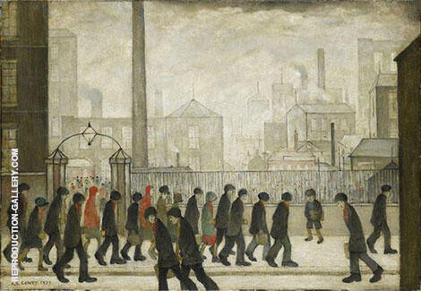  Key Fact: Many famous paintings are of royals, leaders and wealthy people; poorer, ordinary people do not get artists’  attention as often. |  | Ford Madox Brown created a painting simply called Work. It shows a Victorian London street scene during a time of massive change. The painting shows people of different classes.
Lowry’s paintings often feature busy towns and capture scenes of life in industrial England. Many of his paintings are filled with ‘matchstick people’ – an aspect of his art that he became well known for.

Apart from using facial expression, how can artists show emotions?

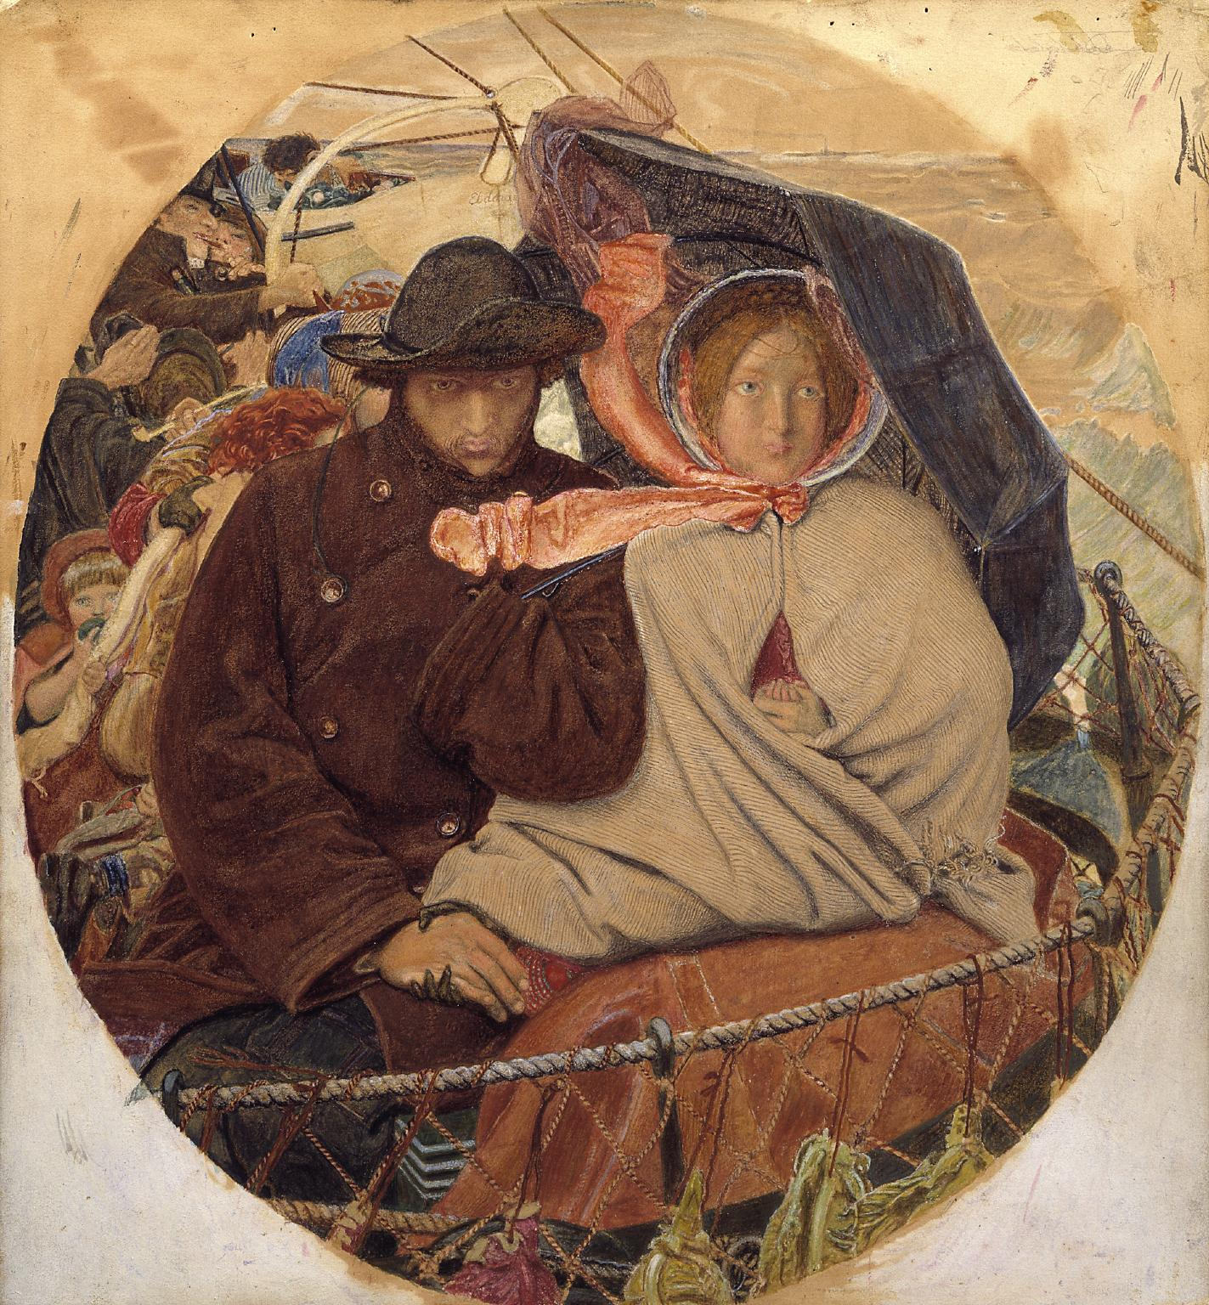
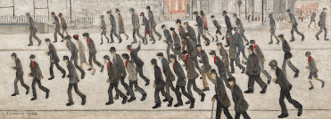
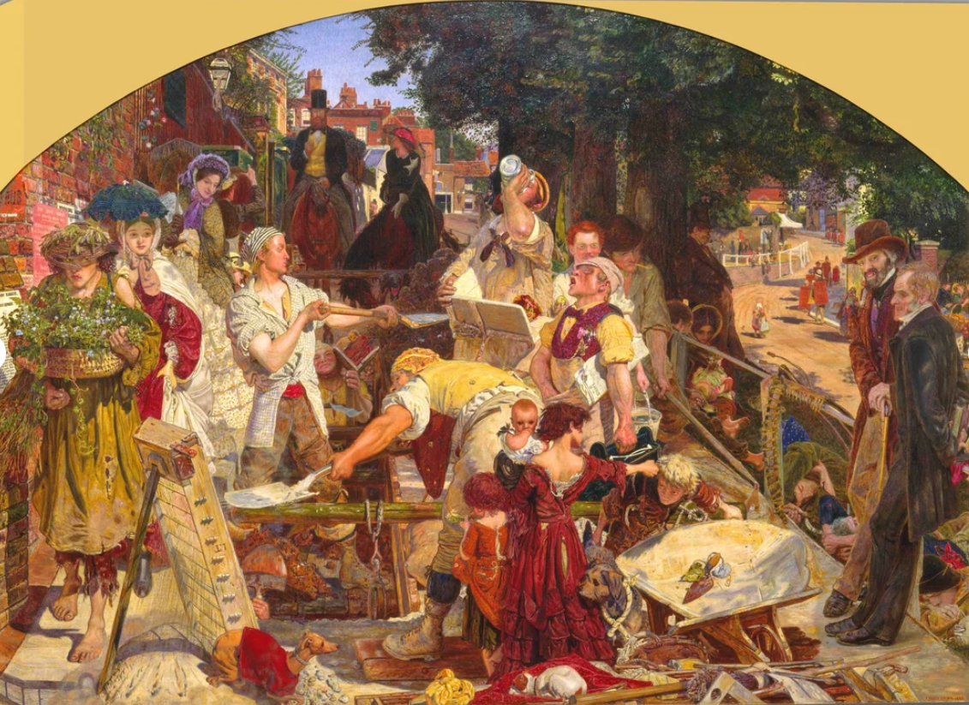

At home:
Find out more about L. S. Lowry: https://www.youtube.com/watch?v=8LMM5LdOVWQ

Create your own matchstick art inspired Lowry.
Visit an online art gallery, such as The National Portrait Gallery https://www.npg.org.uk/visit/

