Year Group: | 4 | Subject: | Science
Term: | Autumn 1st Half | Topic: | Sound and Hearing

Links to Previous Learning |  | What you should know:
sounds can be loud and quiet; high and low. |  | Identify how sounds are made and link to vibrating.
sounds are heard by the ear. |  | Recognise that vibrations from sounds travel through a medium to the ear.

Key Fact: a sound is made when an object vibrates and causes the surrounding air molecules to move.

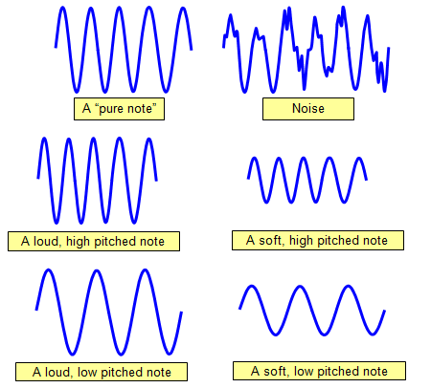
How does vibration make sound travel?

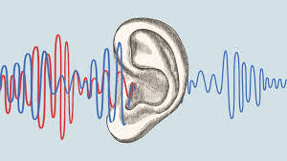

Key Vocabulary
volume | how loud or quiet a sound is
vibration | moving back and forth/ up and down
pitch | the rate at which sound vibrations are made; high or low
sound wave | vibrations of sound

At home investigate:
- how to make loud and quiet or low and high sounds.
- how can whales and dolphins communicate over long distances?

